Chapter 5 Homework

1. Determine the value of *k* so that  with support  is a joint pmf.

|  |  |  |  |  |  |  |
| --- | --- | --- | --- | --- | --- | --- |
|  |  |  |  | X |  |  |
|  |  | 0 | 1 | 2 | 3 | 4 |
|  | 0 | 0.01 | 0.05 | 0.05 | 0.14 | 0.07 |
| Y | 1 | 0.06 | 0.02 | 0.11 | 0.07 | 0.09 |
|  | 2 | 0.18 | 0.03 | 0.04 | 0.05 | 0.03 |

The joint pmf of the random variables *X* and *Y* is given in the table. Use the table for questions 2 and 3.

2. a) Determine  b) Determine  c) Determine d) Determine

3. a) Determine  b) Determine  c) Determine d) Determine

The joint pmf of the random variables *X*, Y and Z is given in the table. Use the table for questions 4 - 9.

|  |  |  |  |  |  |  |  |  |  |  |  |  |  |  |  |  |  |
| --- | --- | --- | --- | --- | --- | --- | --- | --- | --- | --- | --- | --- | --- | --- | --- | --- | --- |
|  |  |  | Z=1 |  |  |  |  |  | Z=2 |  |  |  |  |  | Z=3 |  |  |
|  |  |  |  |  |  |  |  |  |  |  |  |  |  |  |  |  |  |
|  |  |  | X |  |  |  |  |  | X |  |  |  |  |  | X |  |  |
|  |  | 1 | 2 | 3 |  |  |  | 1 | 2 | 3 |  |  |  | 1 | 2 | 3 |  |
|  | 1 | .001 | .002 | .003 |  |  | 1 | .07 | .06 | .01 |  |  | 1 | .03 | .01 | .05 |  |
| Y | 2 | .006 | .005 | .004 |  | Y | 2 | .08 | .05 | .02 |  | Y | 2 | .02 | .145 | .04 |  |
|  | 3 | .007 | .008 | .009 |  |  | 3 | .09 | .04 | .03 |  |  | 3 | .07 | .06 | .08 |  |
|  |  |  |  |  |  |  |  |  |  |  |  |  |  |  |  |  |  |

4. a) Determine  b) Determine  c) Determine  (No need to determine the marginals)

5. a) Determine  b) Determine  c) Determine  (No need to determine the marginals)

6. a) Determine  b) Determine c) Determine (No need to determine marginals)

7. a) Determine  b) Determine c) Determine (No need to determine marginals)

8. a) Determine  b) Determine  c) Determine  d) Determine 

9. a) Determine  b) Determine  c) Determine  d) Determine 

Use  for  to answer problems 10 – 13.

10. a) Determine  b) Determine c) Determine

11. a) Determine  b) Determine c) Determine

12. a) Determine  b) Determine  c) Determine 

d) Determine  e) Determine  f) Determine 

13. a) Determine  b) Determine  c) Determine 

d) Determine  e) Determine  f) Determine 

14. Determine k, so that  is a joint pdf.

15. Determine k, so that  is a joint pdf.

16. Determine k, so that  is a joint pdf.

17. Determine k, so that  is a joint pdf.

18. Determine k, so that  is a joint pdf.

19. Determine k, so that  is a joint pdf.

20 The joint pdf of X and Y is  (region below)

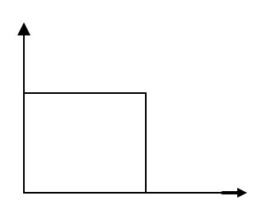a) Determine  b) Determine 

c) Determine  d) Determine 

e) Determine  f) Determine 

g) Determine  and  h) Determine 

i) Determine  j) Determine 

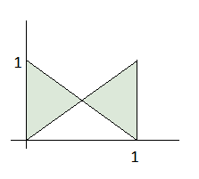21. The joint density of the random variables *X* and *Y* is , where *S* is the region bounded by .

a) Determine  b) Determine 

c) Determine  and  d) Determine  and 

22. Let X and Y be continuous random variables with joint **CDF** (not the pdf)



a) Determine  b) Determine  c) Determine 

d) Determine  e) Determine 

23. The joint pdf of X and Y is  (region below).

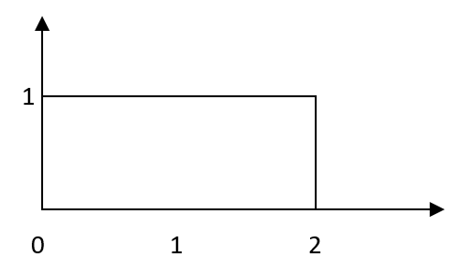a) Determine 

b) Determine 

c) Determine 

d) Determine 

24. Suppose that the joint probability density function of the jointly continuous random variables X and Y is

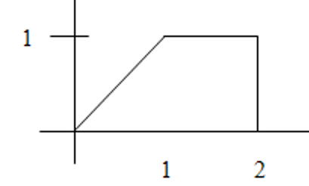

Determine 

25. Let X and Y be continuous random variables with joint pdf .

Given that  and , determine .

26. Given  Determine 

27. Given  and that  and , determine .

28. Let X and Y be continuous random variables with joint pdf .

Given that  and , determine .

29. Determine  for the random variables in problem 23.

30. Determine  for the random variables in problem 24.

31. Given that ,  and:

a) Determine  b) Determine  c) Determine 

d) Determine  e) Determine  f) Determine 

32. Given that ,  and:

a) Determine  b) Determine  c) Determine 

d) Determine  e) Determine  f) Determine 

33. Given that ,  and:

a) Determine  b) Determine  c) Determine 

d) Determine  e) Determine  f) Determine 

34. Given that ,  and:

a) Determine  b) Determine  c) Determine 

d) Determine  e) Determine  f) Determine 